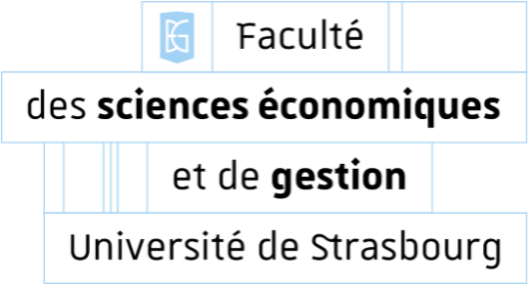

Year 2025/2026
Master 2 Economic Analysis and Policy
Data science for business and business

Big data project: Reinforcement learning agents

LEPETIT Lenny
AZZOUG Dalia
MATT Lucie
NISHARIZE Jeancy Candela

Introduction

Objective of the project: Creation of an agent under the tabular Q-Learning method who will learn to obtain the best possible returns for the prisoner's dilemma against multiple and different opponents.

Two suspects are arrested for an offence committed (illegal carrying of weapons) and the investigators want them to confess to the crime he was going to commit (robbing a bank). If one of the two suspects admits to investigators that their teammate was about to carry out an attack, then the betrayed suspect is released, and the betrayed person gets a 5-year prison sentence. If the two people betray each other, then each suspect gets a four-year prison sentence. If neither betrays their partner and cooperates, then each prisoner is imprisoned for two years in prison. Each year of freedom won compared to the worst situation earns 1 gain, the worst situation being the one where you don't betray your teammate and he betrays you. This situation gives us the following payout matrix:

 | Cooperation | Betrayal
Cooperation | (3 ; 3) | (5 ; 0)
Betrayal | (0 ; 5) | (1 ; 1)

Whatever choice our teammate makes, our gain is greater by betraying it. Indeed, if our partner cooperates, our gain is 3 by cooperating and 5 by betraying him, so we choose to betray him. If our partner decides to betray us, then our co-op gain is 0 while it is 1 by betraying him, so we also choose to betray him. This brings us to a suboptimal situation (1; 1) while it would have been preferable to cooperate to obtain a gain of (3; 3). Indeed, each agent would have had a higher earning, without compromising the well-being of at least one other agent. This situation is called the prisoner's dilemma.

It should be noted that in the initial context, this situation is supposed to occur only once, but in this context we will try to adapt it to a situation where we would be dealing with a sequence of sequences of the same type, with different partners.

The objective of our project is to program an agent who will learn to get the best possible winnings according to these opponents. Indeed, there can be different types of profiles depending on this situation. It may be that our partner trusts us blindly and always decides to cooperate with us and takes the well-being of the team primarily in his arbitration, but it may also be that our partner thinks above all of his individual well-being and betrays us. Having information about our partner's risk profile can be crucial information that should not be overlooked. To highlight this situation, we have imagined different types of typical profiles:

- The cooperant: This person always cooperated with us, whatever our choice, even after several betrayals.
- The Betrayer: This partner will betray us every time.
- Le Tit-For-Tat: In the first round, this teammate cooperated with us. For the following turns, he will do on the Nth turn the action we did on turn N-1.
- The Random: No strategy here, there is a one in 2 chance that he will betray us.
- Copying: This agent will be trained in exactly the same way as our main agent to whom we want to maximize these results. We will train this agent on the first 4 profiles to establish behavior averages. Then we'll use that agent to train our main agent.

The objective is to have a variety of profiles. It is also interesting to see how our main agent will react following the introduction of a new opponent against whom he has no basic information. This copycat agent will have a memory in order to improve the plausibility of our main agent's choices because the objective is to find a solution so that our agent adapts as well as possible.
As a matter of principle, we assume that our agent is not able to know the actions of his opponent but by dint of practice he will have to be able to estimate probabilities on them, at least on the simplest opponents (the first four).

Assumptions:
In the logic of things, against the Cooperant, Betrayer and Random opponents, our agent will always have to betray his partner because the payout will always be higher in the immediate future and the opponent does not adapt. Against the Tit-For-Tat opponent, we think that our agent will have varied choices at the beginning until he understands that the opponent is copying our old choices, and then he will decide to always cooperate.
Against Agent Copie, it is difficult to formulate a hypothesis. Indeed, we must already ask ourselves how to highlight this adversity. Do we have several meetings between our agent and our copy (for example about thirty) and then save this information from these parts in the memory of our main agent so that he can modify his internal policy but the copying agent does not record this new information. As a result, during the second round of meetings between the main agent and the copy agent, the main agent should take advantage of this surplus of information. In the long run, our agent should have higher earnings than the copy agent.
Approach:

Step 1: We set the rules of the game in our code, we implement the opponents with heuristic schemas (the first four agents) and we try to make sure that our agent can adapt to this type of opponent.
Step 2: We register our chief agent with his main decision rules that he has learned. We make a copy of this agent and we call it the Copy agent. From this point on, the copied agent no longer learns but only deals with these learned policies.
Step 3: We define the game sequences between our agent and the copy agent. Each time a sequence of games is completed, our main agent updates its policy. Then he does another game sequence against the opponent Copy.

Base Model

For the first step, our code works as follows:
- Definition of the Gain Matrix
- Definition of adversary classes and their strategies
- Defining agent memory and its policies
- Interaction between the opposing player and the play_match function
- Implementing epsilon evolution and the drive function
- Chart to get and launch.

With this code we get the following graph:
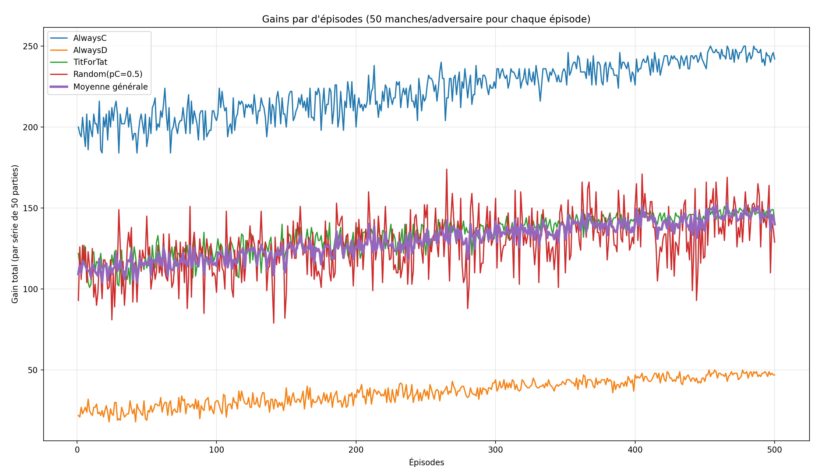

Looking at the following graph, we can ask ourselves: Did our agent learn well?
- Yes, because the expected win is maximized against each of his opponents.
For the case against the opponent AlwaysC, the agent has maximized his performance because when our partner cooperates, we win either 3 or 5, so out of 50 matches per episode, the gain is between 150 and 250. We can see on the graph that for the corresponding curve in blue, the agent has a gain of 200 in the first episodes, i.e. the middle of the interval [150; 250], to tend towards 250 as the episodes progress.
For the AlwaysD opponent, the gain is maximized despite being low because the agent can win either 0 or 1 in each game, so between 0 and 50 per episode. We can see on the graph that for the corresponding curve in orange, the agent has a gain of 25 at the start, i.e. the middle of the interval [0; 50], to tend towards 50 as the episodes progress.
For the opponent Tit-For-Tat, the agent maximized his output as well. Indeed, there is no real long-term equilibrium where the agent would betray the opponent for a better long-term gain because otherwise the opponent will betray him and this will lower his future gains. We notice that the agent learns from the opponent because he does not lock himself into betrayal. Indeed, if he always betrayed him, he would have an average gain of 50 per episode, and if he betrayed him one time out of 2, he would have a gain of (5+0)*50 / 2 = 125, while by always cooperating he obtained a gain of 150 per episode (3*50 = 150). This is what we get at the end of the graph.
For the Random opponent, we cannot know the opponent's choice. The agent has maximized his gain because all he has to do is compare the different possibilities. If the agent always cooperates, he has an average gain of (3+0)*50 / 2 = 75 while if he always betrays, he has an average gain of (5+1)*50 / 2 = 150. Like 150>75, then he has to choose to always betray and we notice that's what he does on the last episodes.

Reading the Q-Table

To validate our agent's learning beyond the simple gain curves, we extracted his "memory" (the Q-Table) at the end of the 500 training episodes. The table below details the Q(s,a) values learned for each possible action against the different opponents. These values represent the discounted cumulative expected gain (γ=0.95).

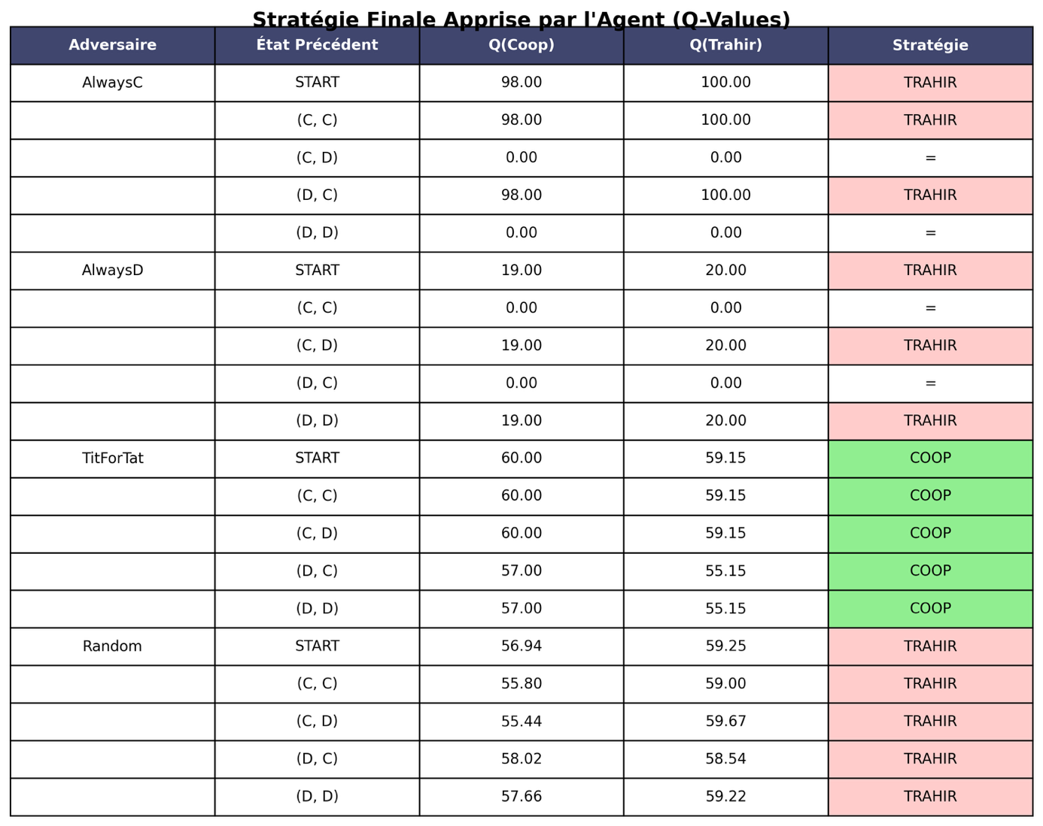
The analysis of these values confirms that the agent has perfectly converged towards the theoretical optimal strategies:
1. Against AlwaysC we have pure exploitation: faced with an adversary who systematically cooperates, our agent has learned to always betray. The Q-Value associated with betrayal reaches the theoretical ceiling of 100.00. This figure corresponds exactly to the infinite sum of the maximum winnings (Temptation T=5) with a discount factor of 0.95:
$Gain max=\frac{5}{1-0.95}=100$
The agent has therefore understood that there is no risk of retaliation and maximizes his profit through exploitation.
2. Against AlwaysD we observe a rational defense: against an opponent who always betrays, the agent has learned that it is useless to cooperate (gain of 0). He therefore systematically chooses to betray to minimize his losses (gain of 1). The value converges to 20.00, which corresponds to the Nash equilibrium of the repeated game (infinite mutual punishment):
$Gain min=\frac{1}{1-0.95}=20$
3. Against Tit-For-Tat, the agent has learned to cooperate in all states, despite the immediate temptation to betray. The value of cooperation stabilizes around 60.00, which corresponds to the reward for mutual cooperation (R=3) in the long term:
$Gain coop=\frac{3}{1-0.95}=60$
We note that the value of betrayal (about 59.15) remains lower. The agent therefore "understood" that the immediate gain from a betrayal (5) would be followed by retaliation that would reduce his total gain expectation. He therefore favours an "honest" strategy out of well-understood interest.

4. Against Random: Risk management in the face of random behavior, the agent mostly favors betrayal. The values are noisier, but the mathematical expectation of betrayal remains higher to protect against the risk of obtaining the "dupe's gain" (0).
This analysis of the Q-Table proves that our algorithm does not just react randomly: it has truly identified the nature of each adversary and has converged on the mathematically optimal strategy for each of them (exploitation, defense or cooperation).

3. Model extension; Duel vs. Copy Agent (Frozen)
In this extension of the model, we are introducing a particular new adversary called Agent Copy. Unlike the previous heuristic profiles (Cooperant, Betrayer, Tit-For-Tat, and Random), this Copy agent is not defined by a simple rule. It matches an exact copy of our main agent after his initial training against the previous four profiles.
In other words, both agents have the same table of Q values at the start and therefore the same initial knowledge of the game. However, a fundamental difference is introduced later:
- the chief officer continues to learn,
- Agent Copy is frozen, meaning it no longer updates its decision policy and only plays in a greedy manner.
This configuration allows us to simulate a realistic situation where our agent faces an opponent who is a priori equivalent, but unable to adapt in the long term.
The purpose of this extension is therefore to observe whether, from an identical starting point, an agent capable of learning can gain an advantage over a fixed copy of itself.

How the duel works:
The duel works as follows:
- The two agents play a series of 50 rounds per episode.
- In each round:
  - The main agent chooses his action with a ε-greedy strategy, which allows him to continue exploring,
  - The Copy agent always chooses the action that maximizes its Q value (ε = 0).
- At the end of each round, only the main agent updates his Q table.
- The Copy agent maintains the exact same policy throughout the experiment.
This confrontation is repeated over 200 episodes, and we record the total payout of each agent per episode, this gives us the graph below:

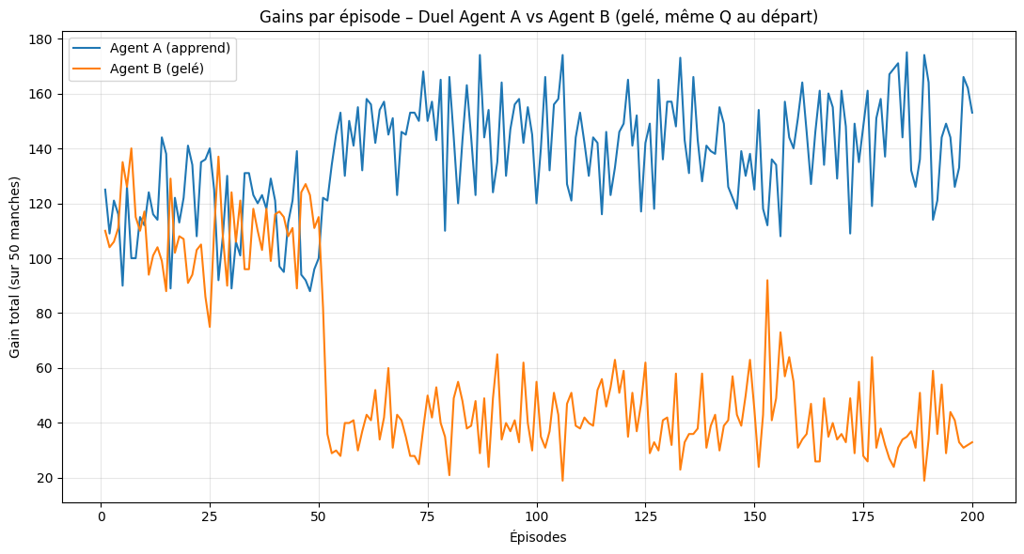
Looking at the following graph, we can ask ourselves:
Did our main agent learn well against an initially identical opponent?
The answer is yes, because the expected earnings of the main agent gradually becomes higher than that of the copy agent. (blue graph)

Case of the duel against Agent Copy (frozen)
At the beginning of the experiment, the two agents have exactly the same Q table and therefore the same decision policy. It is therefore logical that, on the first episodes, their earnings are close.
Out of 50 rounds per episode, the maximum possible win for an agent is between:
- 50 (if both agents betray in each round: 1 × 50),
- 250 (if the agent still betrays while the opponent is cooperating: 5 × 50).
We can see on the graph that, during the first episodes, the main agent (blue curve) obtains a gain of around 90 to 140, which corresponds to an intermediate situation where no dominant strategy is yet clearly identified. The Copy agent (orange curve) exhibits similar behavior, which is consistent since it applies the same initial policy.

Progressive learning of the chief agent
As the episodes go by, the main agent continues to learn while the Copy agent remains frozen. We then observe a clear divergence between the two curves.
For the chief agent, the earnings per episode gradually increase to stabilize around 150 to 170. This indicates that the agent is learning to leverage the Copy agent's decisions to maximize their long-term performance.
Conversely, the Copy agent's gain drops sharply and is mostly between 30 and 60 per episode. This level of gain corresponds to an unfavorable situation where the Copy agent often finds himself betrayed by the main agent, without being able to adapt his strategy.

Strategic interpretation of results
This is because the Copy agent has a fixed policy. The Principal Agent then gradually identifies the states in which:
- Betraying is more profitable than cooperating,
- or cooperating temporarily makes it possible to provoke an actionable reaction from the adversary.
Thus, the main agent learns a strategy that maximizes his average gain, while the copy agent remains stuck in a policy that has become suboptimal against an adaptive opponent.
We therefore observe a situation where:
- the main agent obtains gains close to 3 to 4 per round on average,
- Agent Copy often gets gains close to 0 or 1, corresponding to the worst outcomes of the prisoner's dilemma.
Analysis of the cooperation rate of the duel:
In addition to the analysis of earnings per episode, we study here the cooperation rate of the two agents during the duel between the main agent and the copy agent. This rate corresponds to the proportion of rounds during which an agent chooses to cooperate on a series of 50 rounds per observation episode.
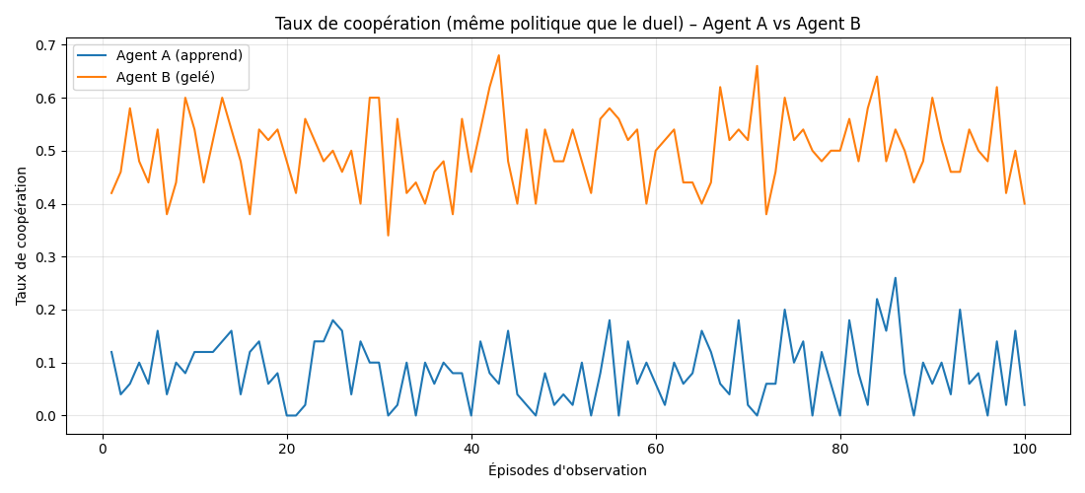
It can be observed that the cooperation rate of the main agent is generally low, fluctuating mainly between 0% and 20% depending on the observation episodes.
This result indicates that the primary agent very rarely cooperates with the Copy agent. This behavior is consistent with the previously observed earnings analysis. Indeed, when faced with an opponent whose policy is fixed, the chief agent learns that it is more profitable, in the long term, to betray frequently in order to maximize his gain.
Thus, the low cooperation rate reflects an exploitative strategy: the main agent favors betrayal in the majority of situations, which allows him to achieve high gains per episode.
Conversely, the cooperation rate of the Copy agent is much higher, mostly between 40% and 65%.
This behavior is because the Copy agent is a frozen copy of the main agent after its initial training against heuristic opponents. In this initial learning environment, cooperation could be a cost-effective strategy, especially in the face of the Tit-For-Tat adversary.
However, the Copy agent does not adapt to the evolving behavior of the primary agent. He therefore retains a relatively high propensity to cooperate, even when this strategy becomes suboptimal against an opponent who learns and exploits this regularity.

4. Conclusion
The initial objective of this project was to design an agent capable of learning by reinforcement (via the Q-Learning algorithm) to maximize its gains in the context of the iterated prisoner dilemma facing multiple adversaries.
At the end of our experiments, we validated three major results. First of all, unlike a fixed strategy, our agent demonstrated his ability to identify the nature of his opponent in order to adopt the optimal response. The analysis of the final Q-Table confirmed that he learned to exploit passive agents (AlwaysC), to defend himself against aggressors (AlwaysD) and to cooperate sustainably with a reciprocal agent (Tit-For-Tat), thus reaching the social optimum (R=3). Then, the expected gain values (Q-Values) learned by the agent correspond precisely to the theoretical mathematical expectations. This proves the robustness of the implementation and the convergence of the algorithm towards the optimal solutions (Nash equilibrium or Pareto optimum depending on the opponent). Finally, the extension of the model via the duel against the "copy" agent highlighted the importance of real-time learning. Although the copy agent possessed an excellent initial strategy, his inability to adapt left him vulnerable. The main agent was able to detect this rigidity and exploit it, demonstrating that a dynamic strategy always prevails over a static strategy in a changing environment.
Despite these convincing results, our model has certain inherent limitations in its architecture, which constitute avenues for future work. Our agent makes his decision only based on the previous turn (t−1). He is therefore "blind" to complex strategies that would be based on longer cycles (for example, an opponent who betrays every 3 turns). The resulting improvement would be to increase the size of the state to include the history of the last 3 or 5 hits, which would allow more subtle patterns to be detected. Another limitation of this model is that the increase in memory would cause a combinatorial explosion in the number of states, making the tabular approach obsolete. We could then use Deep Q-Networks (DQNs) that would allow us to approximate the value function without storing a gigantic table, opening the way to much richer strategies. A final relevant improvement would be to introduce noise (uncertainty about the action of the other) in order to get closer to real scenarios, given that this project illustrates in a simplified way fundamental dynamics observable in economics (price wars, oligopolies) or in international relations.

References
Sandholm & Crites (1996) :
Sandholm, T. W., & Crites, R. H. (1996). Multiagent reinforcement learning in the Iterated Prisoner's Dilemma. Biosystems, 37(1-2), 147-166.
Harper et al. (2017) :
Harper, M., Knight, V., Jones, M., Kertesz, A. D., Campbell, J., & Glynatsi, N. E. (2017). Reinforcement learning produces dominant strategies for the Iterated Prisoner’s Dilemma. PloS one, 12(10), e0184223.

